QUIZ
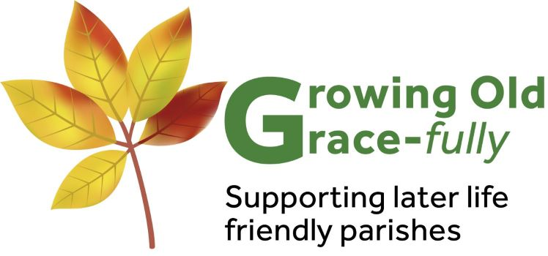

The witness of Growing Old Grace-fully is to God’s gift of age, both to older people themselves, to the wider Church and the whole community.

We hope this Quiz will help to open the discussion to consider God’s gift of age, “the greatest triumph and challenge of the 21st century” (WHO 2002), and to reflect on how we are all responding to that challenge as part of the Church’s mission.

Older People Today
The expectations of older people have changed dramatically.

- The average life expectancy in 1900 was 47 and it is now 87.
How much is the human lifespan increasing every day, as an estimate?
□ 5 seconds □ 5 minutes □ 5 hours (Source: Nesta 2013)

- How many million people in Britain are over the state pension age?
□ 10 million □ 11 million □ 12 million (Source: Gov’t Actuary’s Dept)

- What is the estimated percentage of the population that are over 85?
□ 2% □ 5% □ 7.5 % (Source: Gov’t Actuary’s Dept)
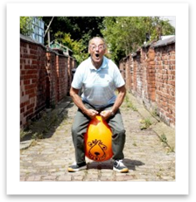

- The proportion of people with dementia doubles for every 5 year age
group. What percentage of people aged 90 and over have dementia? □ 13% □ 27% □ 33% (Alzheimer’s Society, Statistics, 2009)

- What is the chance of living in a long-stay hospital or care home for
people aged 85+?
□ 16% □ 20% □ 24 % (Source: Age UK, 2013)

Older People’s Value
Older people offer huge benefits to society.

- There are 6.5million unpaid carers in the UK, but how many are over 65?
□ 500,000 □ 1million □ 1.2million (Source: Carers UK Briefing Oct 2015 )

- What is the estimated value of the informal care provided by older people every year?
□ £1.8billion □ £5.5billion □ £11.4billion (Source: Gov’t Actuary’s Dept )

- What is the estimated amount of childcare that grandparents deliver free every year in Britain?
□ £10million □ £1billion □ £7.3billion (Source: Grandparents Plus/Age UK, May 2013 )

- What percentage of people aged 65 and over take part in volunteering or civic engagement?
□ 25% □ 58% □ 90% (Source: Age UK Older People as Volunteers Review, 2013 )

- What is the estimated amount over 65s contribute to the UK economy AFTER deduction of costs and pensions?
□ £10billion □ £25billion □ £40billion (Source: Women’s RVS/King’s Fund Ageing Report, 2012 )

Older People and Church
The UK is made up of an ageing population, and that includes the Church.

- What was the estimate of the proportion of older parishioners in each Deanery?
□ 50% □ 35% □ 25% (Source: CSAN Older People’s Services, 2009 )

- What did the majority of Church Leaders identify as the main challenge facing older people?
□ Mental health □ Poverty □ Loneliness & isolation (Source: CSAN Older People’s Services, 2009 )

- How many visits to older people do the St Vincent de Paul Society make in a year in the UK?
□ 50,000 □ 65,000 □ 75,000 (Source: CSAN Older People’s Services, 2009 )

- According to a recent survey by Dr Peter Brierley, Director of Christian Research, over a third of people aged 64-74 have a “sense of belonging to a church”. What proportion have this
“sense of belonging” aged 85 or more?
□ over half □ a quarter □ less than a fifth

This Quiz is taken from the ‘Welcoming Older People’ Parish Pack (2017) produced by Growing Old Grace-fully. For more details of the full pack see our website https://www.growingoldgracefully.org.uk/ or email us at growing.old.gracefully@dioceseofleeds.org.uk

