QUIZ
ANSWERS
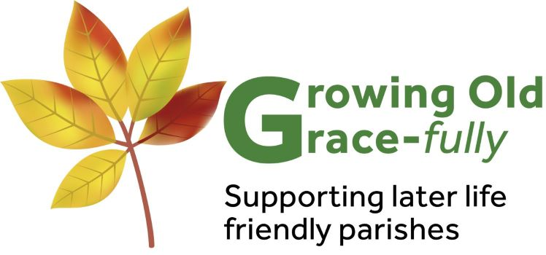

THIS COPY IS FOR THE QUIZ MASTER.
The correct answers are in bold and underlined.

Older People Today
The expectations of older people have changed dramatically.

- The average life expectancy in 1900 was 47 and it is now 87.
How much is the human lifespan increasing every day, as an estimate?
□ 5 seconds □ 5 minutes □ 5 hours (Source: Nesta 2013)

- How many million people in Britain are over the state pension age?
□ 10 million □ 11 million □ 12 million (Source: Gov’t Actuary’s Dept)

- What is the estimated percentage of the population that are over 85?
□ 2% □ 5% □ 7.5 % (Source: Gov’t Actuary’s Dept)
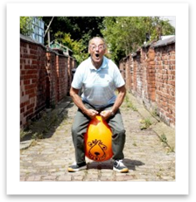

- The proportion of people with dementia doubles for every 5 year age
group. What percentage of people aged 90 and over have dementia? □ 13% □ 27% □ 33% (Alzheimer’s Society, Statistics, 2009)

- What is the chance of living in a long-stay hospital or care home for
people aged 85+?
□ 16% □ 20% □ 24 % (Source: Age UK, 2013)

Older People’s Value
Older people offer huge benefits to society.

- There are 6.5million unpaid carers in the UK, but how many are over 65?
□ 500,000 □ 1million □ 1.2million (Source: Carers UK Briefing Oct 2015 )

- What is the estimated value of the informal care provided by older people every year?
□ £1.8billion □ £5.5billion □ £11.4billion (Source: Gov’t Actuary’s Dept )

- What is the estimated amount of childcare that grandparents deliver free every year in Britain?
□ £10million □ £1billion □ £7.3billion (Source: Grandparents Plus/Age UK, May 2013 )

- What percentage of people aged 65 and over take part in volunteering or civic engagement?
□ 25% □ 58% □ 90% (Source: Age UK Older People as Volunteers Review, 2013 )

- What is the estimated amount over 65s contribute to the UK economy AFTER deduction of costs and pensions?
□ £10billion □ £25billion □ £40billion (Source: Women’s RVS/King’s Fund Ageing Report, 2012 )

Older People and Church
The UK is made up of an ageing population, and that includes the Church.

- What was the estimate of the proportion of older parishioners in each Deanery?
□ 50% □ 35% □ 25% (Source: CSAN Older People’s Services, 2009 )

- What did the majority of Church Leaders identify as the main challenge facing older people?
□ Mental health □ Poverty □ Loneliness & isolation (Source: CSAN Older People’s Services, 2009 )

- How many visits to older people do the St Vincent de Paul Society make in a year in the UK?
□ 50,000 □ 65,000 □ 75,000 (Source: CSAN Older People’s Services, 2009 )

- According to a recent survey by Dr Peter Brierley, Director of Christian Research, over a third of people aged 64-74 have a “sense of belonging to a church”. What proportion have this
“sense of belonging” aged 85 or more?
□ over half □ a quarter □ less than a fifth

This Quiz is taken from the ‘Welcoming Older People’ Parish Pack (2017) produced by Growing Old Grace-fully. For more details of the full pack see our website https://www.growingoldgracefully.org.uk/ or email us at growing.old.gracefully@dioceseofleeds.org.uk

